COVER PAGE

Crafting Dairy Excellence - From Our Farms to Your Table
Where Responsible Farming Meets Refined Dairy Innovation
Artisanal Cheese • Premium Dairy Processing • Timeless Craft
Replace Content:
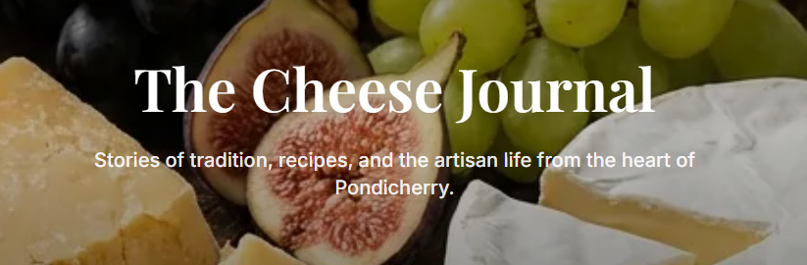
The Cheese Journal - From Curd to Culture
Stories of tradition, craft, and the slow art of affinage from the artisan cellars of Pondicherry.
Replace Content:
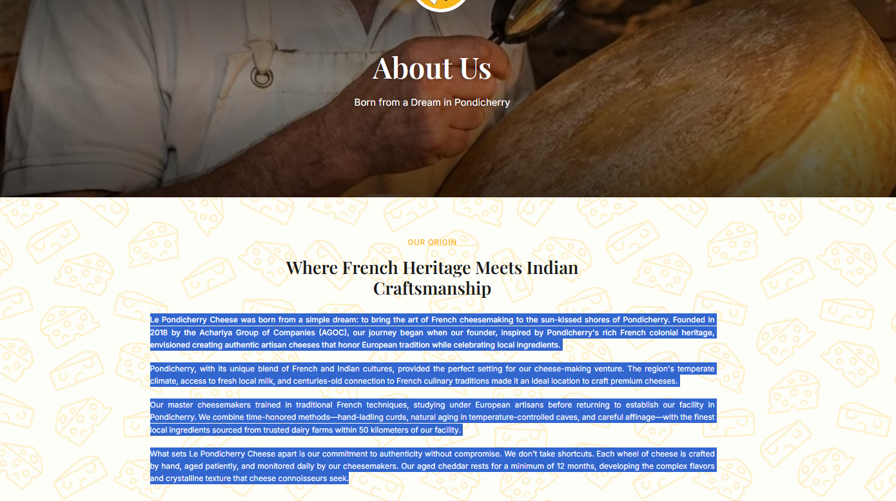

About Us:
Le Pondicherry Cheese is an artisanal cheese brand born in the historic coastal town of Pondicherry where rich dairy heritage meets refined European cheese-making traditions.
Each cheese is handcrafted in small batches, using fresh, locally sourced cow’s milk, time-honoured techniques, and carefully controlled ageing processes.
We believe in purity above all. That’s why our cheeses are made with: Zero preservatives, No artificial additives and Clean, honest ingredients only.
From delicate fresh cheeses to rich, aged gourmet varieties, every product reflects our philosophy:
Patience. Purity. Craftsmanship.
At Le Pondicherry Cheese, we don’t just make cheese we celebrate the art of cheese-making.

A Brand By

Comatha Agro & Dairy Enterprises Private Limited
Le Pondicherry Cheese is proudly produced by Comatha Agro & Dairy Enterprises Private Limited, a dairy enterprise founded in 2019 by Dr. Arawindhan J.
What began as a farm-based dairy initiative has grown into a modern dairy processing enterprise, rooted deeply in ethical practices and quality-first principles.
Replace Content:
Achariya Group of Companies
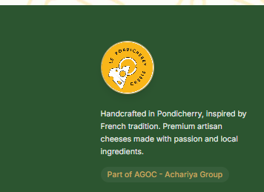

Founder’s Message
Dr. Arawindhan J - Founder
"Our vision has always been to build a dairy enterprise that respects both nature and science. Starting from a farm-based foundation, we have worked with dedication to create products that reflect purity, quality, and authenticity.
At Comatha Agro & Dairy Enterprises, we believe that great dairy products begin with responsible farming, careful processing, and a commitment to excellence.
Our journey is driven by the passion to bring premium dairy experiences to consumers while maintaining the highest standards of integrity and sustainability.
We look forward to continuously innovating and expanding our reach while staying true to our values of quality, trust, and responsibility
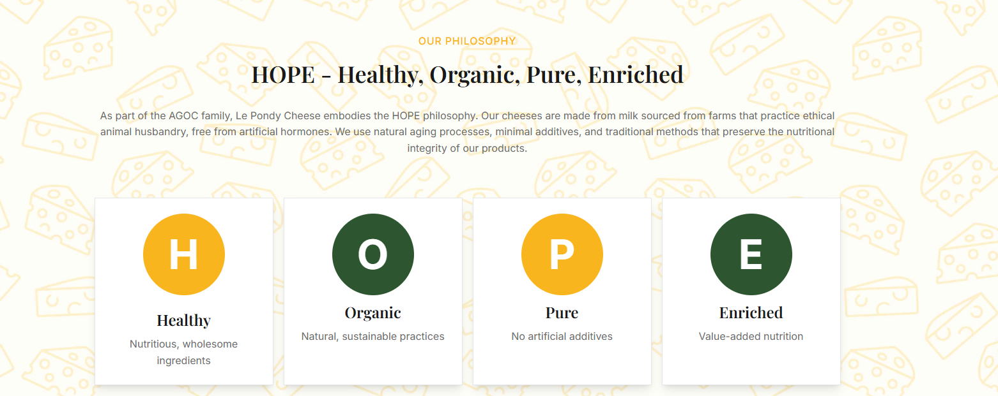
Replace Content:
Eyebrow label: A Creed We Live By
Headline: Not just cheese. A philosophy in every rind.
Body copy: At Le Pondicherry, we believe what goes into our cheese matters as much as what comes out of it. Sourced from ethically raised herds, aged without shortcuts, and crafted free from compromise every wheel carries a promise: pure goodness, from pasture to plate.
H — Healthy Nourishing by nature, not design
O — Organic Farmed with care, never with chemicals
P — Pure Nothing hidden, nothing artificial
E — Enriched Richer in nutrition, richer in meaning

Replace Content:

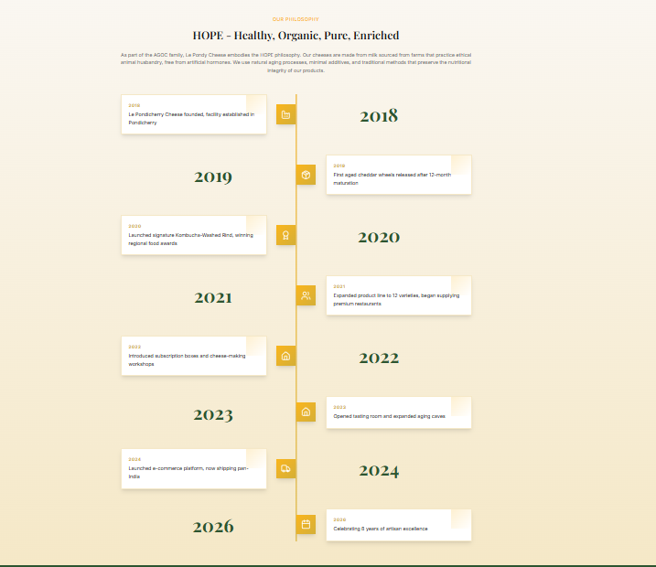

Our Journey
Eyebrow: Our Journey
Headline: Eight years of craft. One unbroken promise.
Subline: Founded on conviction. Grown through patience. Defined by purity.
2018: The Vision Takes Root - A farm. A belief. A beginning.
Dr. Arawindhan J. establishes Le Pondicherry Cheese in the heart of Pondicherry built on ethical farming, honest milk, and a quiet determination to do things differently.
2019: Learning the Language of Quality – Processes refined. Standards set.
The foundation made unshakeable. Before a great cheese can be made, a great system must be built. We invested in the invisible the disciplines, the rhythms, and the rigour that no label can capture.
2020:The Craft Begins - Our first wheels turn.
The Kombucha-Washed Rind earns its first admirers. Milk processing comes to life. Value-added dairy takes shape. And one audacious recipe our signature Kombucha-Washed Rind announces us to the world.
2021: From Artisan to Institution - Twelve varieties. India's finest kitchens.
One unwavering standard. State-of-the-art equipment arrives. Safety systems are elevated. And Le Pondicherry quietly becomes the name that premium restaurants across India trust.
2022: Bringing the Cave to You - Subscription boxes. Workshops.
The art of cheese, made personal. We opened our world to yours with curated boxes delivered to your door and hands-on workshops that turn curiosity into craft.
2023: An Invitation to Taste - The tasting room opens.
The aging caves deepen. The story becomes an experience. For the first time, guests could walk in, sit down, and let the cheese speak for itself. Our cave grew larger. Our welcome, warmer.
2024: Pondicherry to Every Doorstep - Pan-India shipping.
A platform built to carry our promise, everywhere. With the launch of our e-commerce platform, distance stopped being a barrier. From Pondicherry to your table every order, a small act of trust we take seriously.
2026: Still Crafting. Still Committed.
Eight years young and only getting started. Innovation, sustainability, and an unrelenting pursuit of purity. This is not where our story peaks. It is where it deepens.

Our Vision
To build COMATHA AGRO & DAIRY ENTERPRISES PRIVATE LIMITED into a trusted dairy enterprise while establishing Le Pondicherry Cheese as a premium artisanal cheese brand known for its craftsmanship, natural quality, and refined taste.

Our Mission
- Manufacture premium-quality dairy and cheese products using scientifically controlled processing systems.
- Maintain the highest standards of food safety, hygiene, and quality assurance.
- Continuously improve operational efficiency through modern technology and skilled workforce development.
- Build long-term relationships through reliability, transparency, and trust.
- Expand product portfolio and market reach while maintaining consistency and integrity.

OUR ARTISANAL CHEESE PROCESS
Every cheese at Le Pondicherry Cheese is crafted through a mindful, artisanal process:
Step 1: Fresh Milk Collection
Milk is collected at dawn from trusted local farms.
Step 2: Gentle Heating & Culture Addition
We use natural cultures to develop flavour and texture.
Step 3: Curd Cutting & Hand Stirring
Curds are cut and stirred manually for perfect consistency.
Step 4: Shaping & Pressing
Each cheese is shaped in small moulds to ensure quality.
Step 5: Natural Ageing
Our Swiss and hard cheeses are aged for weeks or months under controlled humidity.
Step 6: Hand-Cutting & Packing
Every batch is tested, cut, and packed with care.
This patient, traditional process is what gives our cheese its freshness, flavour, and authenticity.

EXPLORE OUR CHEESE COLLECTION

1. PONDY ORANGE (Cheddar-Style Cheese)
A Pondicherry-made Cheddar-style cheese inspired by classic English cheddar-making methods. Pondy Orange gets its name from its rich golden-orange hue and sharp, tangy flavour profile.

Origin Style: Inspired by English Cheddar

Flavour Notes: Tangy, sharp, savoury, bold

Ageing: Medium-aged for flavour development

Best For: Mac & Cheese • Burgers • Baked dishes • Snacking

Why It’s Special:
✔ Strong flavour profile
✔ Perfect for melting & grating
✔ One of our most flavourful cheeses

2. BABY SWISS
A young Swiss-style cheese with a delicate sweetness and mellow nuttiness. It has the classic Swiss characteristics but with a creamier, smoother texture.

Origin Style: Swiss Alpine cheese

Flavour Notes: Nutty, buttery, slightly sweet, mild tang

Ageing: 2 months

Best For: Sandwiches • Fondues • Omelettes • Salads

Why It’s Special:
✔ Softer, less rubbery than traditional Swiss
✔ Melts beautifully
✔ Great for everyday cooking

3. HALLOUMI
A Mediterranean-style firm cheese known for its ability to hold shape under heat - the perfect grilling cheese.

Origin Style: Cypriot / Middle Eastern

Flavour Notes: Salty, savoury, clean dairy taste

Ageing: Fresh & lightly brined

Best For: Grilling • Frying • Wraps • Healthy bowls

Why It’s Special:
✔ High-protein snack
✔ Doesn’t melt - gets golden & crispy
✔ Vegetarian favourite

4. MOZZARELLA (FRESH)
A soft, milky Italian-style cheese made fresh daily. Offers a clean flavour and stretchy melt.

Origin Style: Italian fresh cheese

Flavour Notes: Milky, light, mildly tangy

Ageing: No ageing - consumed fresh

Best For: Pizzas • Pasta • Salads • Sandwiches

Why It’s Special:
✔ Perfect pizza stretch
✔ Soft, moist, premium artisan quality

5. PIZZAELLA (LOW-MOISTURE MOZZARELLA)
Designed especially for chefs and pizzerias, this cheese offers ideal melting, browning and longer shelf life.

Origin Style: Professional low-moisture mozzarella block

Flavour Notes: Creamy, mild, lightly salty

Ageing: Slightly aged for firmness

Best For: Pizzas • Baked dishes • Garlic breads

Why It’s Special:
✔ Longer shelf life
✔ Perfect browning
✔ Easy to grate & cube

6. BOCCONCINI
Soft mozzarella pearls with refreshing tang and delicate stretch - perfect for gourmet cold plates.

Origin Style: Italian soft cheese balls

Flavour Notes: Fresh, milky, mildly tangy

Ageing: No ageing; stored in brine

Best For: Caprese salad • Pasta bowls • Appetizers

Why It’s Special:
✔ Elegant presentation
✔ Loved in premium cafés & restaurants

7. FETTA
A crumbly, tangy cheese inspired by classic Greek Feta. Brings brightness and saltiness to any dish.

Origin Style: Greek brined cheese (Indian adaptation)

Flavour Notes: Slight tang, salty, fresh, savoury

Ageing: Brined for flavour

Best For: Salads • Dips • Stuffings • Mediterranean bowls

Why It’s Special:
✔ Adds instant flavour
✔ Crumbles perfectly
✔ High demand for salad bowls

8. RICOTTA
A soft, cloud-like cheese that is naturally sweet. Extremely versatile across sweet and savoury recipes.

Origin Style: Italian whey cheese

Flavour Notes: Sweet, creamy, delicate

Ageing: Fresh - no ageing

Best For: Desserts • Pasta fillings • Toasts

Why It’s Special:
✔ Very light and fluffy
✔ Used in premium bakery & dessert menus

9. PANEER
Fresh Indian cottage cheese, soft and versatile - a daily cooking essential in Indian households.

Origin Style: Indian dairy staple

Flavour Notes: Mild, creamy, neutral

Ageing: No ageing; always fresh

Best For: Curries • Grills • Snacks • Rolls

Why It’s Special:
✔ Soft yet firm
✔ Doesn’t crumble easily
✔ Freshly made daily

10. DADDY SWISS
A bold version of Swiss cheese for customers who enjoy stronger, aged flavours.

Origin Style: Aged Swiss cheese

Flavour Notes: Tangy, salty, robust

Ageing: 3+ months

Best For: Pasta • Sandwiches • Cheese boards

Why It’s Special:
✔ Stronger flavour profile0
✔ Great for bold dishes
✔ Premium gourmet choice

11. YOUNG SWISS
A soft, mild Swiss cheese aged only two weeks - perfect for beginners and light meals.

Origin Style: Swiss cheese (young version)

Flavour Notes: Light, nutty, soft

Ageing: 2 weeks

Best For: Breakfast • Crackers • Kids’ meals

Why It’s Special:
✔ Kid-friendly flavour
✔ Soft & easy to slice

12. GRANA CHERY (AGED HARD CHEESE)
A Parmigiana-inspired hard cheese with intense savoury umami and nutty flavour.

Origin Style: Italian Parmigiano/Reggiano-style

Flavour Notes: Strong umami, nutty, savoury, sharp

Ageing: Aged over 6 months

Best For: Pasta • Risotto • Salads • Steaks

Why It’s Special:
✔ Amazing grated topping
✔ Long ageing = deep flavour
✔ Premium gourmet cheese
Why Choose Le Pondicherry Cheese?
100% Natural - Made without preservatives or additives.
Farm-Fresh - Crafted from milk collected daily from Pondicherry farms.
Handcrafted in Small Batches - Better flavour, texture, and quality control.
European Style, Indian Heart - Inspired by traditional French and Swiss cheesemaking.
Versatile Range - From soft fresh cheese to aged varieties - something for every kitchen.
Trusted by Chefs - Preferred by restaurants, cafes, hotels, and home cooks.
Storage & Handling Guide
Refrigeration: Store cheese at 2°C – 6°C.
After Opening:
Wrap in butter paper or parchment - avoid plastic wrap.
Consume:
- Fresh cheeses within 3–5 days
- Firm cheeses within 10–15 days
- Aged cheeses within 30 days
Before Serving: Leave cheese at room temperature for 10–15 minutes to enhance flavour.
Transportation: Use insulated boxes or ice packs for maintaining freshness.
Chef’s Suggestions :
i. For Sandwich Shops: Use Baby Swiss, Mozzarella, or Young Swiss for melts.
ii. For Italian Restaurants: Stock Grana Chery, Ricotta, Pizzaella, Bocconcini.
iii. For Cafes/Bakers: Use Ricotta and Mozzarella for pastries, quiches, desserts.
iv. For Indian Cuisine: Best choices include Paneer, Fetta, Grana Chery.
v. For Grills & Healthy Menus: Halloumi is your best protein-packed option.
Packaging & Wholesale Options:
Available Packaging:
- 200g
- 400g
- 600g
- 800g
- 1kg (bulk)
Wholesale Benefits:
- Consistent quality
- Long shelf life for firm cheeses
- Special pricing for bulk orders
We Supply To: Cafes, Restaurants, Bakeries, Hotels, Caterers and Retail outlets.
Bulk pricing & custom packaging available.
CONTACT US:
Preamkumar (VP) - +91 72005 04628
Noorullah (Plant Incharge) - +91 93609 01010

